PSD

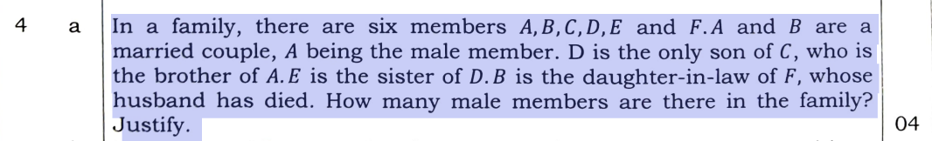

A and B are a married couple, with A being the male member.
C is the brother of A. Since A is male, C is also male.
D is the only son of C, making D male.
E is the sister of D, meaning E is female.
B is the daughter-in-law of F, who is a widow (her husband has died).

From this, we can summarize the male members = 3
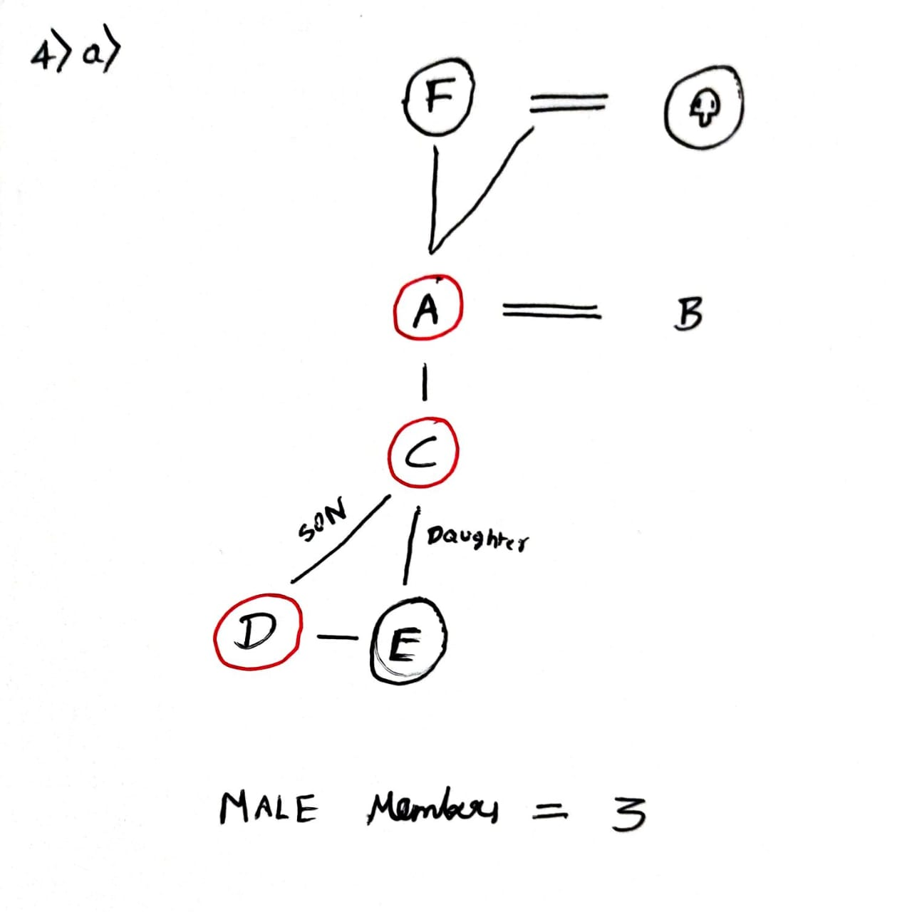

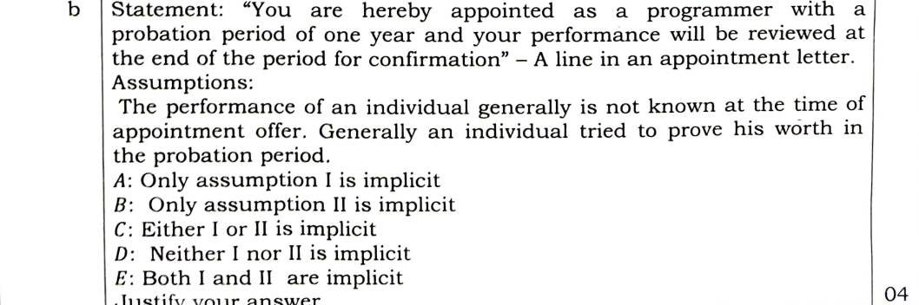

E: BOTH I and II are implicit
Assumption I: "The performance of an individual generally is not known at the time of appointment offer."
Assumption II: "Generally an individual tries to prove his worth in the probation period."

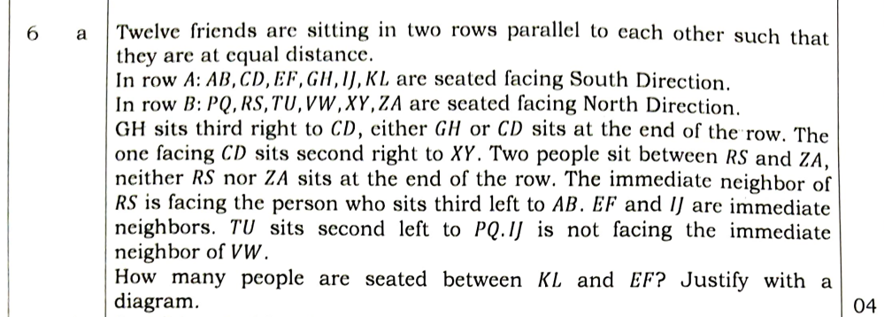

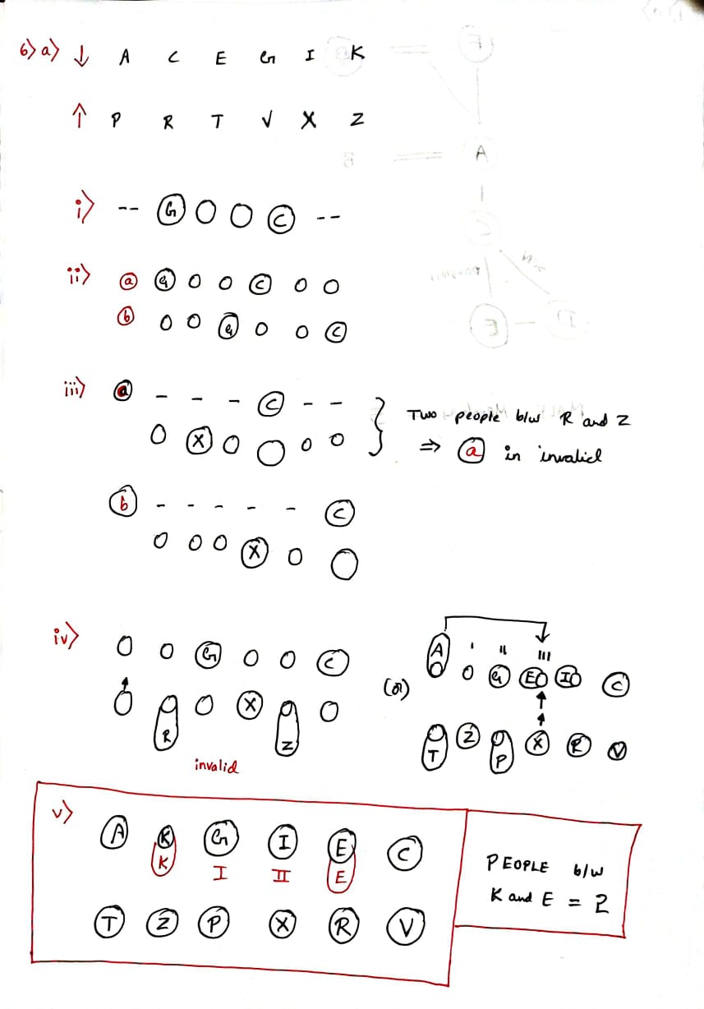

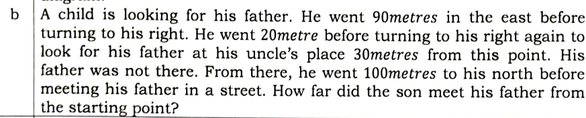
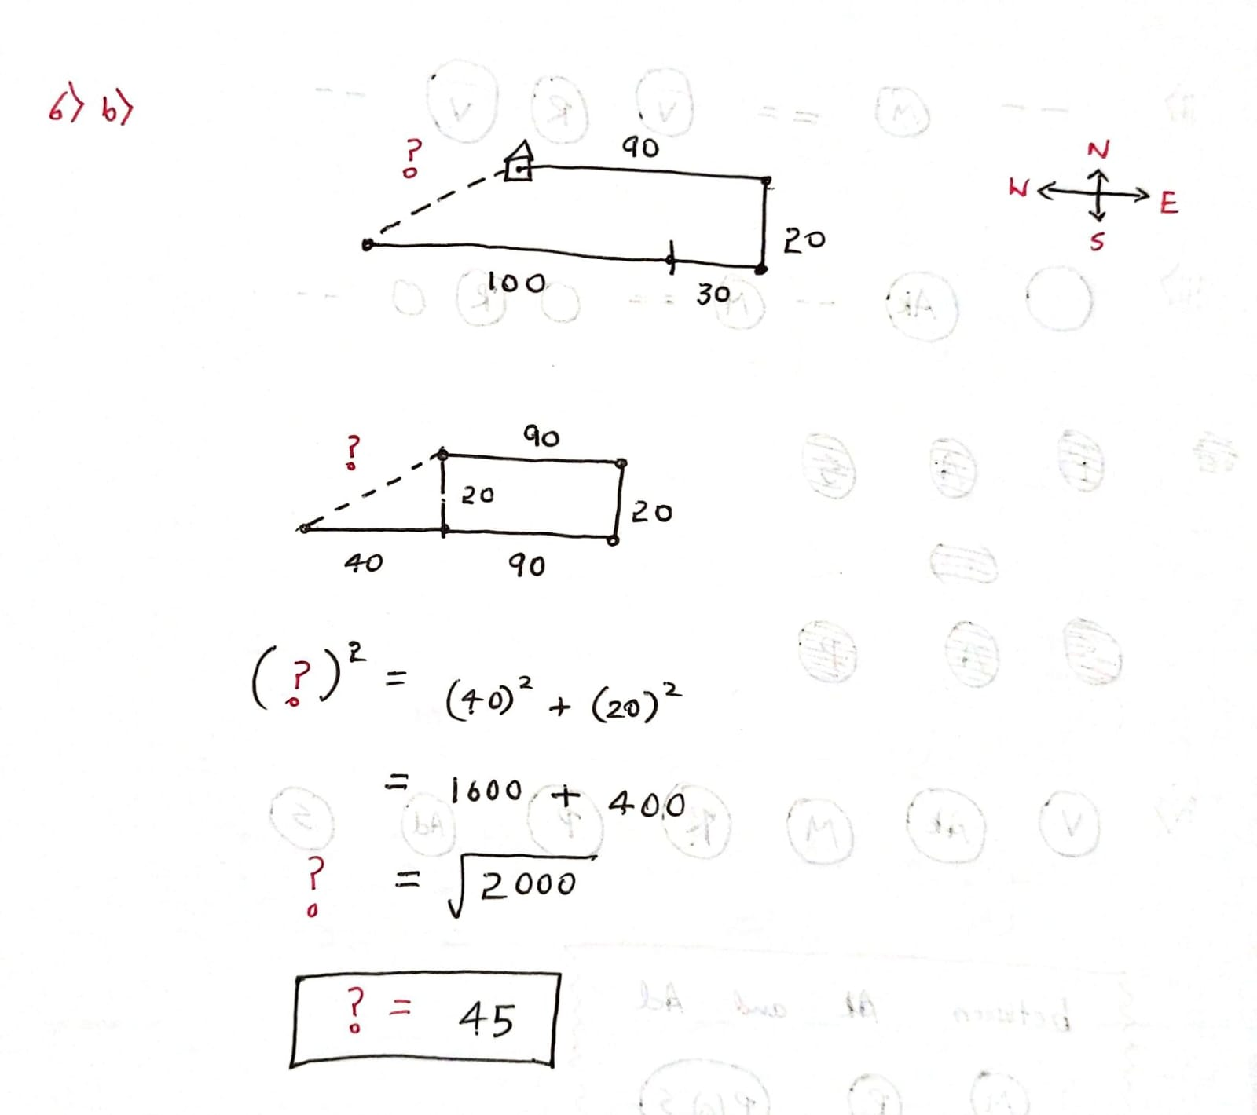

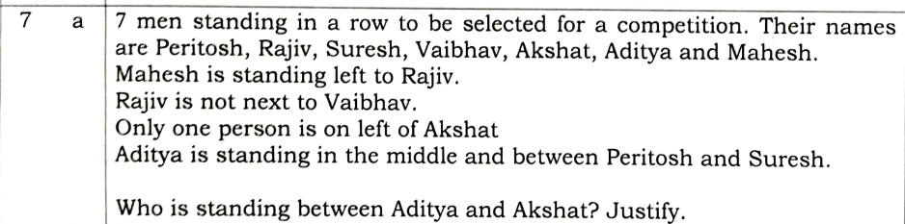
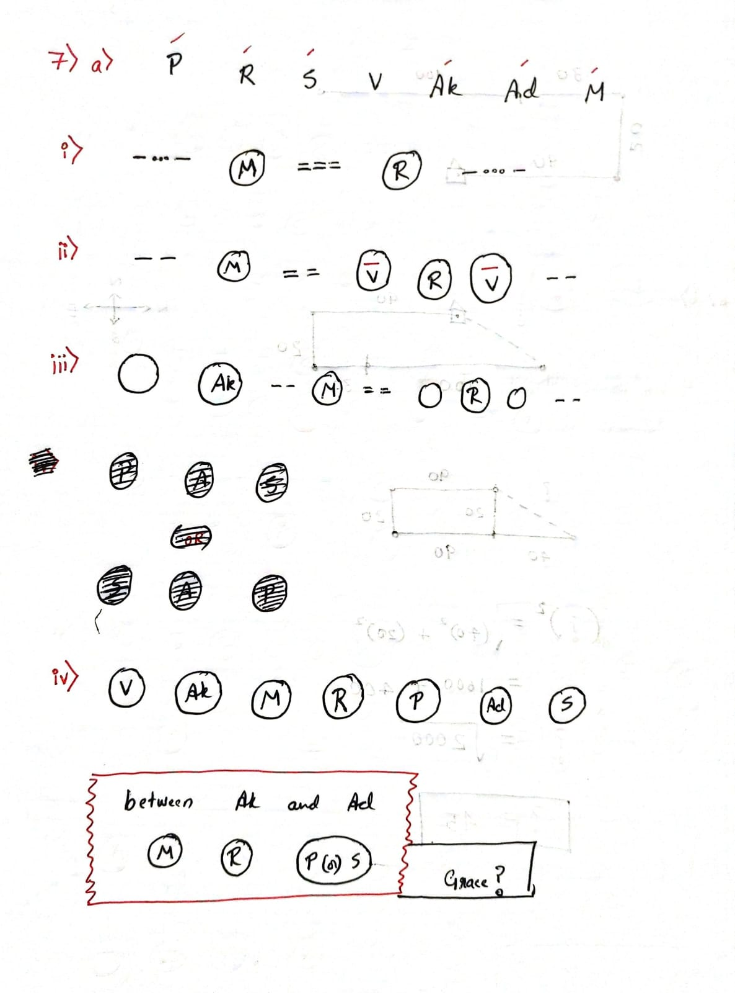

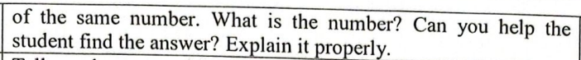

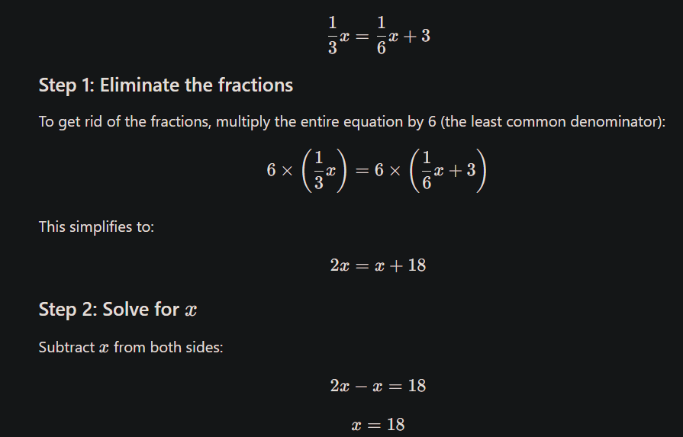

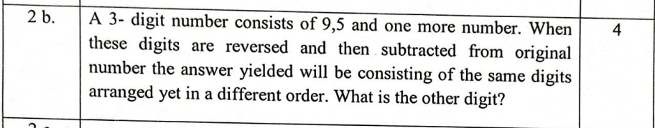
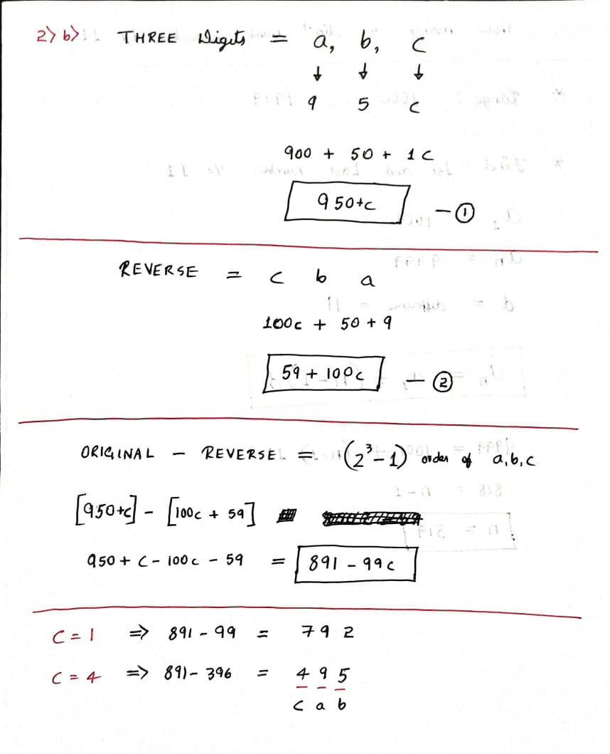

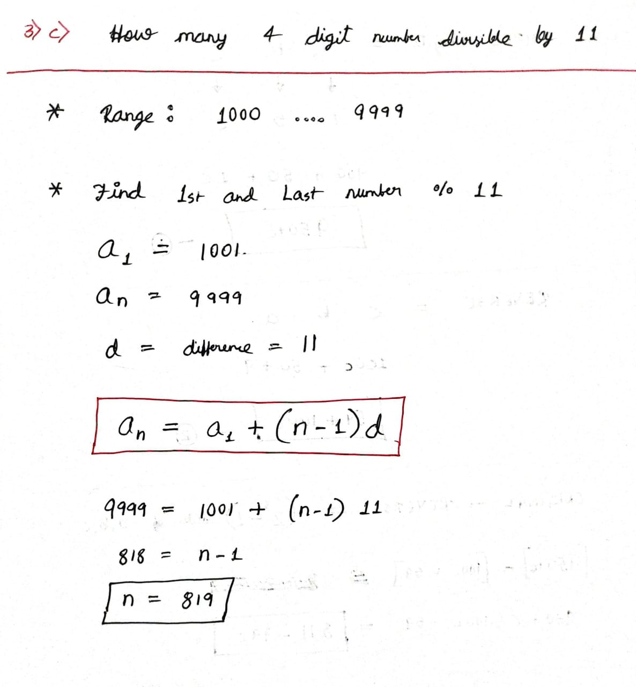

ss

